# Durable Furnitures

Baker

## Nest Pendant

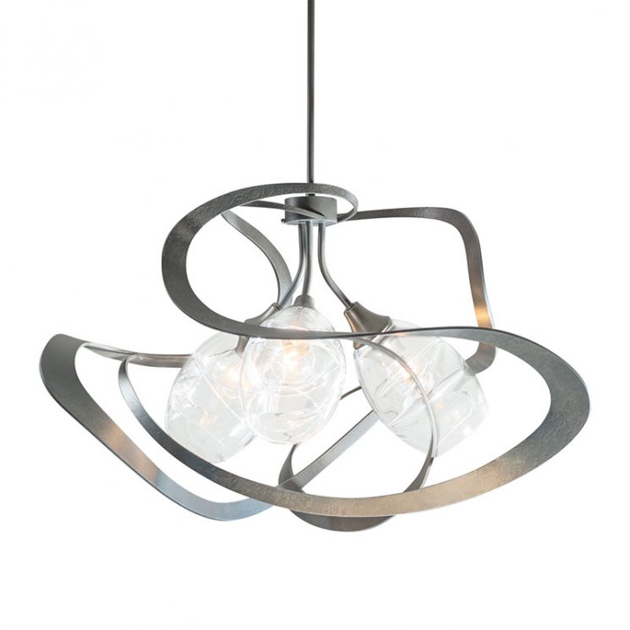

The Nest Pendant from Hubbardton Forge conjures up images of three baby birds safely nestled at its center with its twining steel outer form surrounding three clear glass sources of light. Organic lines combine with industrial construction to form the essence of this handcrafted modern light fixture. Contoured details in the blown glass shades add an extra subtle detail that encourages all to take a closer look. Create the perfect focal point for your dining area with a Nest Pendant of your own.